Session 2 lab Programs

Ch. Bhargav Ram (192425334)
Session 2
03-10-26
EXP 1:
Program:
def unique_elements(arr):
unique = []
for x in arr:
if x not in unique:
unique.append(x)
return unique
arr = [1, 2, 2, 3, 4, 3, 5]
print(unique_elements(arr))
Output:
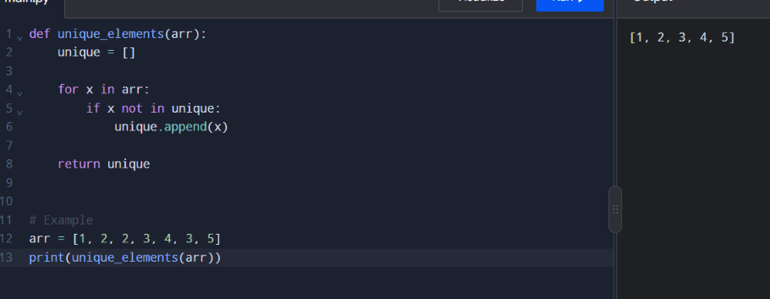

EXP 2:
Program: Output
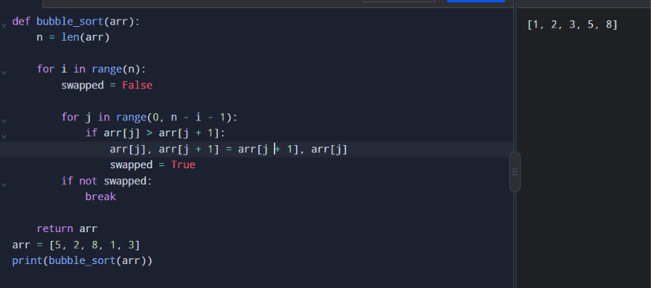

Exp 3:
Program: Output
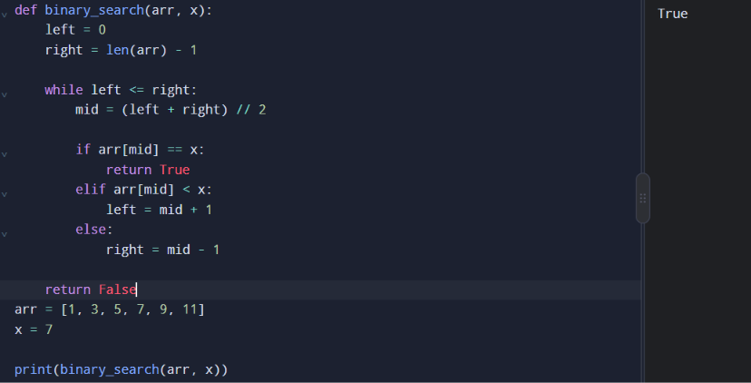

Exp 4:
Program: Output
